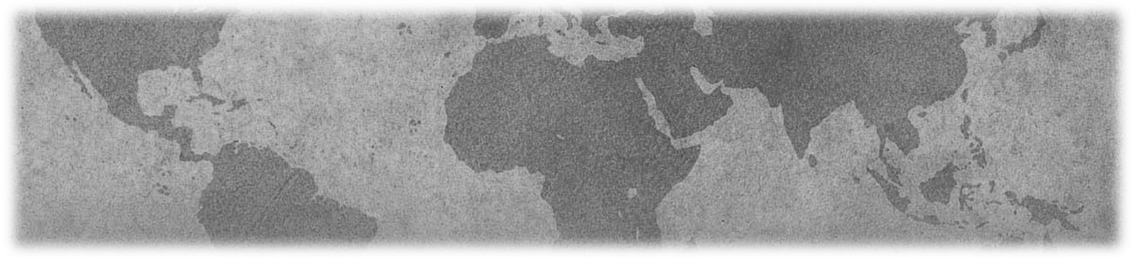Purpose
2014 TLS Gathering – November 14-16, 2014
The Duncan Center, Delray Beach, Florida
Embracing Liminal Space

Poster Presentation Guidelines
Call for Presentation Proposals
2013 TLS Gathering: September 17-22, 2013

Labyrinths for Global Healing, Landscapes for the Soul

Poster Presentation Guidelines
The Poster Showcase provides a forum for those who work with labyrinths to share their best practices and/or research in a poster format with other professionals in the field.

Content

The content presented must be the original work of the author(s). Poster proposals should be submitted in one of two categories:

- Best practices posters should describe innovative labyrinth methods, programs, trainings, or projects implemented by the author in worksite, hospital, school, community, or other settings.
- Research posters should describe the author’s research (findings or evaluation of a study, project or new program) that contributes to the base of knowledge about labyrinths, their effects, and how they work.
- For those unfamiliar with poster presentation, we recommend this wonderful and humorous article on designing a poster that may be helpful: http://colinpurrington.com/tips/academic/posterdesign.

Format and Guidelines for Poster Display

- Presenters are encouraged to create 2-dimensional presentations, preferably displayed affixed to the wall with blue painter’s tape (such as ‘Scotch Blue’). A limited number of floor easels and 2' × 6' tables are available for presentations which require these display methods. Please note: due to floor space limitations, posters requiring easels or tables may be on display only during the 60 minute poster workshop session.
- Typical poster dimensions are 3’ x 4’ and include the title of your presentation, your name, affiliation, and any co‐authors, as well as detailed information outlined in the poster proposal. Visual aids should be legible from a distance of at least 3 feet. Graphics should be simple, colorful, well‐labeled, and legible. You may wish to have extra copies of your findings available for distribution, although this is your responsibility.
- Poster presenters are responsible for bringing their own supplies. Technical equipment (such as data‐lines, TV/DVD player) will not be provided. All material used to display the poster, as well as any handouts, will be the responsibility of the author. Contact the Workshop Chair if you have questions or concerns.
- Posters will be on display during a poster workshop session which will be specified in the Gathering Program.
- In order to receive reimbursement, the author must be present during the 60 minute poster workshop session to engage in dialogue and address questions from Gathering participants. Please be aware: The poster workshop session does not lend itself to formal presentations.
- Presenters are responsible for removing their posters at the close of the poster session.

Please note: Poster displays are opportunities for sharing, not selling. Authors who wish to market products or services are encouraged to purchase a vendor table or offer sales through the TLS Store.

