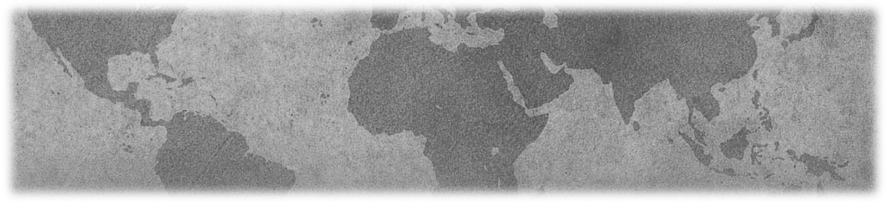
Purpose
Poster Presentation Guidelines
2017 TLS Gathering – October 27-29, 2017
Island Wood, Bainbridge, Washington
“Honoring the Labyrinth Environment:
Co-Creating With Nature”
The Poster Showcase provides a forum for those who work with labyrinths to share their best practices and/or research in a poster format with other professionals in the field.

Content

The content presented must be the original work of the author(s). Poster proposals should be submitted in one of two categories:

- Best practices posters should describe innovative labyrinth methods, programs, trainings, or projects implemented by the author in worksite, hospital, school, community, or other settings.
- Research posters should describe the author’s research (findings or evaluation of a study, project or new program) that contributes to the base of knowledge about labyrinths, their effects, and how they work.
For those unfamiliar with poster presentation, we recommend this wonderful and humorous article on designing a poster that may be helpful: http://colinpurrington.com/?s=designing+posters

Format and Guidelines for Poster Display

- Presenters are encouraged to create light-weight, 2-dimensional presentations, preferably displayed affixed to the wall with blue painter’s tape (such as brand name: ‘Scotch Blue’).
- Display Methods: posters should be light enough to affix to the wall successfully with tape because many facilities do not allow tacks or anything that would damage the walls.
  - Footnote: Depending upon the facility, a limited number of floor easels and 2' × 6' tables may be available. However, this is not a guarantee. Please contact the Workshop Chair if you have questions or concerns.
- Dimensions/Formatting: Typical poster dimensions are 3’ x 4’ and include the title of your presentation, your name, affiliation, and any co‐authors, as well as detailed information concerning your topic. Visual aids should be legible from a distance of at least 3 feet. Graphics should be simple, colorful, well‐labeled, and legible. You may wish to have extra copies of your findings available for distribution, although this is your responsibility.
- Poster presenters are responsible for bringing their own supplies. Technical equipment (such as data‐lines, TV/DVD player) will not be provided. All material used to display the poster, as well as any handouts, will be the responsibility of the author. Contact the Workshop Chair if you have questions or concerns.
- Posters will be on display during a poster workshop session which will be specified in the Gathering Program.
- In order to receive reimbursement, the author must be present during the 60 minute poster session to engage in dialogue and address questions from Gathering participants. Please be aware: The poster session is informal in nature and does not lend itself to formal presentations.
- Presenters are responsible for removing their posters at the close of the poster session.

Please note: Poster displays are opportunities for sharing, not selling. Authors who wish to market products or services are encouraged to purchase a vendor table or offer sales through the TLS Store.

